**Programming Technology**

**Assignment 1**

Shafaqat Iqbal

PMR75L

Date: 09/10/2021

Task 6

Choose a point on the plane and fill a collection with several regular shapes (circle, regular triangle, square, regular hexagon). **How many shapes contain the given point?**

Each shape can be represented by its center and side length (or radius), if we assume that one side of the polygons are parallel with x axis, and its nodes lies on or above this side. Load and create the shapes from a text file. The first line of the file contains the number of the shapes, and each following line contain a shape. The first character will identify the type of the shape, which is followed by the center coordinate and the side length or radius. Manage the shapes uniformly, so derive them from the same super class.

So basically, we need to find the shapes on a given point on a plane.

We read File which number of shapes on first line and then shape followed by coordinates.

Class UML Diagram

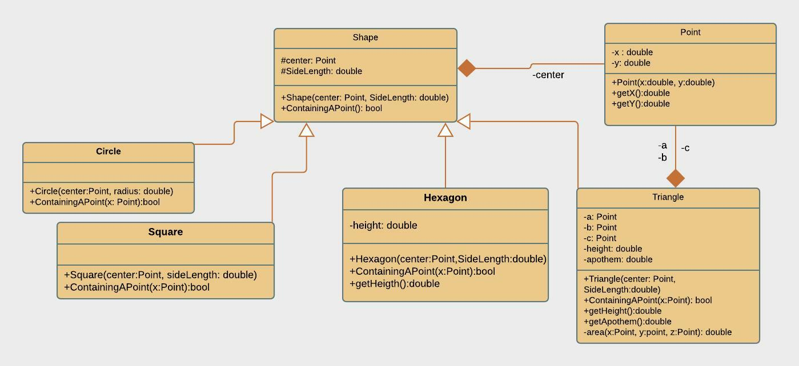

Description of Methods:

**Point Class**:

This class has attributes of coordinates and constructor along with getters of those coordinates.

**Shape Class:**

This class contains a center and side Length along with the constructor of shape, and an abstract method for checking the point within the shape. ContainingAPoint();

**Triangle Class:**

This class is extended from shape class, it has 3 vertices, height, and an apothem for a triangle.

With some methods of calculating the total area, then checking the point

**Hexagon:**

This class in extended from shape class and has methods of getting a height as it is also composed of 6 triangles, then checking whether it contains point in it or not.

**Square:**

This class is extended by shape class, and it has a constructor and method for checking the point in it.

**Circle:**

This class is extended by shape class, and it has a constructor and method for checking the point in it.

**Tests:**

1: **Wrong output name error.**

This will give an error of not having the right name of the input file or file not found exception.

2: **Empty File**

If the input file is empty, then it will give illegal exception of not having the right order of input.

3: **Right Input:**

10

s 0 0 5

t 0 0 5

C 0 0 5

c 0 0 5

s 0 0 5

t 0 0 5

h 0 0 5

c 0 0 5

s 0 0 5

s 0 0

4: **NullPointException:**

2

s 0 0 1

If the number of objects do not match, then this error will arise.

5: **Illegal argument exception**:

s 0 0 5

If the order does not match, then it will show such show error of file starting with illegal character.

6: **Index out of bound exception:**

If some entry is missing, then this error will pop out.

2

c 0 0 3

s 0 0